Dear Primed for your Life Reader,

I'll keep this email short as I would ideally love to talk to you any time personally. My cell is 0929-421-2148 if you wish to discuss this in more detail.

Some other benefits to going Primed besides getting better cholesterol results are:

You WILL get more energy, have better bowel functions, better mental clarity, more enjoyment from food, be fuller, be happier, have better skin, less aches and pains, no stomach issues and WILL be fighting disease as opposed to feeding it.

Your metabolic markers would improve exactly as mine have done.

Please watch this 31 minute youtube video when you can from Professor Tim Noakes. He is one of the smartest men on the planet in terms of nutrition.

Here he admits his cheap processed carb promotion was wrong and he even now has diabetes. It is very interesting: https://www.youtube.com/watch?v=6WVLrQmnnAY

Please also see this from Dr. Peter Brukner (club doctor for Australian cricket team) where he even relates to his own cholesterol level marker improvements: https://www.youtube.com/watch?v=JMuD4Z-Oxys

Your brain is 60% fat, Mother's milk is 50% fat and cheap manufactured carbs like grains are useless and damage your health. Too many Filipinos are eating the SAD diet. SAD is an acronym for Standard American Diet.

Look where that has us and them: with obesity, heart disease, diabetes, cancer, ADHD, autism, Alzheimer's etc. through the roof and in epidemic proportions. Right?

Please also see story at the bottom of here. I have so many more like this. Maiqui from Fitness First, Jonah from Sante Barley, me, my wife Natasha, Jualyn and his wife, David Richmond, Anna Rodriguez, Mae Ilagan (cured PCOS), ADB staff (cured irritable bowel syndrome) and over 80of my corporate clients that experienced positive health outcomes.

Here are my metabolic markers for cholesterol below. They indicate excellent cardiovascular health.

However, when in doubt, ask the person how they feel. I feel great. I have energy all day. I just ran a 3:30 marathon. I just got a personal best at Tri-U 1 on March 1st by exercising less than I have ever done.

How do you feel? Do you feel great? Do you have sustained energy all day? If not, why not? We should not blame age as that is a poor excuse that people use.

I could go on all day but will leave it at this. I can back up everything and would be glad to talk to you in more detail as mentioned if you wish.

Cheers and good luck on achieving better health.

Thanks,

Chad.
Disclaimer: Obviously I am not a doctor or medical professional. I have however researched some of the brightest doctors and people on the planet and have learned through them, my experience and the experience of my hundred plus people I coach to improved health.

Chad’s Cholesterol Panel Results for Past 3 Years

 | Chad | Chad | Chad
 | 2013 | 2014 | 2015
HDL - go high | 85 | 126 | 151.35
LDL | 129 | 148 | 212.55
Triglycerides - type of fat | 63 | 24 | 37.63
Total Cholesterol | 217 | 282 | 371.43
Total HDL ratio | 2.6 | 2.2 | 2.5
Tri to HDL | 0.74 | 0.19 | 0.25
Cardiovascular risk | Low | Lower | Excellent

A ratio of 2:1 is considered good.
A ratio of 1:1 is considered excellent.
Mine is .25 at the moment.

Some Further Explanation About The Cholesterol Panel from Ben Greenfield

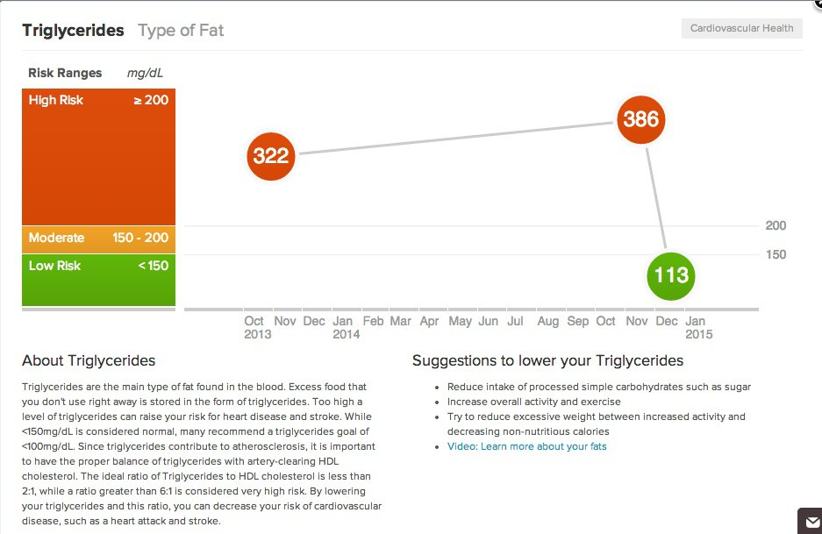



PRIMED LIFESTYLE

PRIMED FOR YOUR LIFE DEREK ACKARY
MARCH 5, 2015 CHADDAVIS1PRIMEDFORYOURLIFE LEAVE A COMMENT EDIT
G’day mate,
Thanks for adding my before and after pic to your facebook/instagram. Hopefully I can be a source of inspiration to others.
Here’s my story:
Two of my best mates passed away recently, both within 9 months of each other. My first mate died one week before his 49th birthday in November 2013. He was massively overweight and led a fairly unorthodox lifestyle, and didn’t exercise. Being with him made me feel that if he could live that way, so could I, even though deep down, I knew it was leading to a path of destruction. But then I was in for a bigger shock 9 months after he passed on…
My other mate had a better lifestyle – he made efforts to eat well and exercise, but was a massive smoker and under lots of stress from his job. He died in August 2014, 8 months after turning 50. This left me absolutely shattered. Two of my best all time mates, two of the best blokes you would ever meet, gone within 9 months of each other. Both of these guys were actually also mates and left us well before their time with various complications, as opposed to dying of “natural” causes. However, it was the second death happening so soon after the first that motivated me to take action for myself. I wanted to give myself the best chance in life to achieve my goals such as traveling the world (in a fit, mobile manner), and spending time with my family – life long time. Soon after that, by a chance encounter, I bumped into Chad in October 2014. Although I already knew Chad, I hadn’t seen him for several years. Up to that point, I had already made some changes and had in fact lost some weight since my friend had passed on in August however, Chad was the missing piece of the jigsaw and gave me the motivation to make more of a change. Less than six months later, here I am!
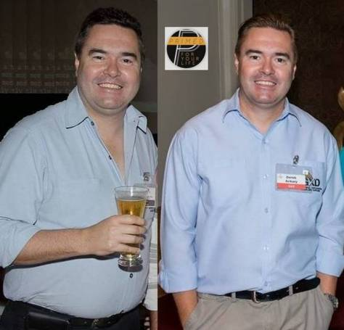

FACTS:
July 25, 2014 weighed 98kg
Started Primed around Nov 14, 2014 weighing 94.5kg
March 5 weight is 84.7kg
Goal weight 81kg
Do eccentric gym for approx 70 mins per week (2 sessions x 35 mins)
Interval training (high intensive cardio) for approx 50 mins per week (2 sessions x 25 mins).
Go for a casual jog around village for approx 30 mins once per week (approx 4.5kms)
Walk around the village for approx 60 mins once per week (approx 6kms)
Total exercise per week 210 mins (3.5hrs) four days per week.
Fast every day for 16 hours (skip breakfast) to increase ketones and reduce insulin. When I reach goal weight I will add back breakfast to maintain weight.
Here is a list of things that I have noticed since going Primed:
Zero flatulence
Cuts and wounds healing quicker
Mentally sharper, no fogginess
More energy
Less sleepiness and feeling drained
Blood count better (triglycerides and cholesterol) down
No longer taking triglyceride meds. I’m no longer a health risk according to my doctor
Haven’t had a cold/flu despite whole family/work mates/friends getting it (although I do consume two lemons/day)
More strength re weightlifting
Losing weight
Sleeping a bit better
Less body stiffness
Bowel movements aren’t sticky and come out better
Virtually zero diarrhea (not that I would have it too often but now hardly ever – probably more so from eating out less)
In summary, I eat great healthy foods, cook more, eat more and enjoy food more and what’s more, feel great. I’m never going back to sugar or gluten!
I’m not sure if there is anything else you want to add/edit mate, but that’s about it really. Let me know if there is anything else…
Cheers

